Switching Controller Tuning

Owen Lu

Electroimpact Inc.

owenl@electroimpact.com

*Abstract*—In order to tune the servo creel system properly, a general understanding of the various control constants and their constraints is instructive. This paper details the baseline example of how to select constants based on add/cut speed and motor torque.

# Hardware Limitations

First of all it is important to understand the hardware limitations, most notably the maximum RPM that can be generated from the motor gearbox combination. This dictates what is theoretically possible in terms of maximum surface speed. For example, the SM23166MT has a limit of 4500RPM from the specifications. In practice with the gearbox, and slightly lower operating voltage (46VDC) we can consistently get 4000RPM as a maximum speed. We then compute the output speed and multiply by the circumference of the smallest spool during operation.

|  |  |  |
| --- | --- | --- |
|  | $$\frac{4000RPM}{10}⋅3.5πin=4396ipm$$ | (1) |

Thus, any commands above approximately 4400ipm are unreasonable in the program as small spools may result in dancers hitting the end of travel. In the next sections we will see that the dancer travel limit plays a large role in the control parameters.

# Basic Model

In terms of the behavior of the control system can be separated into two separate control loops to analyze their behavior. One loop is specifically tuned with a lower gain to reduce torque requirements on cuts and adds, while the other has a higher gain to reduce displacement. The trigger to switch between the two control loops is a condition that simply checks the dancer position. This is called $x_{t}$ the threshold value.

The way the control loop works is non-standard in some sense even though it is based on control of an LTI system. The first control loop looks like a standard loop however, there are a few key characteristics. The disturbance to the system called $v_{o}$ is the payout velocity. The control loop does not reject step or ramp inputs from this disturbance. This means that velocity commands in steady state will result in a steady state displacement from the reference $x_{r}$. This is by design as larger distance is reserved to slow the spool down for larger speeds reducing the torque requirements of the motor.

# Main Parmaters

From the PLC, the parameters that the user can select are listed below:

1. $x_{r}$ the reference dancer position, this can be thought of as an initial tension as well
2. $x_{t}$ the threshold displacement
   1. Once this value is passed the control loop gain is increased
3. $K_{p}$ the controller gain
   1. This is the main parameter that affects dancer displacement, higher values reduce displacement at the cost of torque
4. $K$ the feedback path gain
   1. When dancer displacement passes $x_{t}$ this gain increases $K_{p}$ by a factor of $\left(K+1\right)$
   2. Default to $K=1$

The process to select workable constants is below. Note that this process does not guarantee that good constants in the sense that the dancer displacement limitation is not violated. It is possible that for example the specified speeds require too much torque to reduce the dancer displacement into the feasible range.

1. Specify a maximum output torque from the reducer
2. Calculate the controller gain $K_{p}$
3. Specify an add/cut speed
4. Using the higher value of the add/cut speed calculate the threshold value $x_{t}$
5. Specify the maximum speed below the maximum speed limitation of the motor.
6. Calculate the steady state displacement at the maximum specified speed.
7. Check that the steady state displacement is within the dancer travel and has about 0.25in of space from the end

After this has been done this gives a good base line of controls constants. The first order of business would be to be to conduct testing at 50% add/cut speed and increase to 100% in increments of 10% monitoring torque. This should be done with a full or close to full spool as inertias of the system are estimated. In theory, maximum torque is related to add/cut velocity linearly. Thus, if we test at for example 50% speed and see that the torque is at 25% of maximum, going to 100% speed would approximately result in 50% of maximum torque.

Given the control structure the maximum torque is estimated to be

|  |  |  |
| --- | --- | --- |
|  | $$\max\left(T\right)=\frac{I_{s}}{r_{s}}⋅K_{p}v_{o}e^{-1}$$ | (2) |

Clearly, $I_{s}/r_{s}$ are estimated values therefore, the maximum torque will be scaled incorrectly. This is a way factor of safety can be built into the initial estimation of the constants.

A conservative estimate is given below.

|  |  |  |
| --- | --- | --- |
|  | $$\frac{I_{s}}{r_{s}}=\frac{0.07kgm^{2}}{0.107m}=0.654kgm$$ | (3) |

Thus, it is likely that we have more torque from the motor to work with than we have calculated since we have estimated the inertia to be a larger value than expected (by approximately 15%).

Note that from the equation we can also specify the maximum torque and add/cut speed and calculate the controller gain $K_{p}$.

For example:

|  |  |  |
| --- | --- | --- |
|  | $$\max\left(T\right)=7Nm$$ | (4) |
|  | $$v_{0}=3000ipm=1.27ms^{-1}$$ | (5) |
|  | $$K_{p}=\frac{7e}{1.27⋅0.654}=22.9rads^{-1}$$ | (6) |

Note that the $K_{p}$ value in the PLC has units of $rads^{-1}⋅{10}^{-4}$ thus this value would be specified as a scalar value of $22,900$.

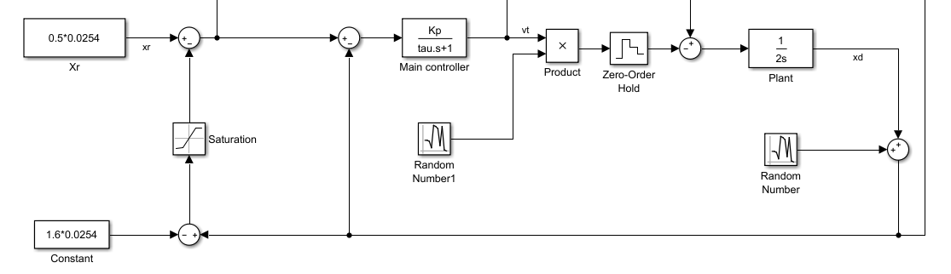

Figure - Switching controller structure

The steady-state displacement is written in Eq. 1.

|  |  |  |
| --- | --- | --- |
|  |  | () |

During initial acceleration to top speed, there is a torque spike as the controller makes a switch the high gain mode. This number is dependent on $K$. Basically the larger $K$ is the larger the torque spike during acceleration. We want to maximize $K$ while keeping torque under a set value. We can see that adding cut speed will linearly increase the dancer displacement

# Parameter selection

In order to test the new control system, the first thing was to reduce the gain as much as possible. A selection with $K_{e}=17.5rads^{-1}$ was observed to significantly reduce slack in the film material. This is down from a nominal value of $25rads^{-1}$ which would imply a 30% peak acceleration reduction.

The next step is to check the steady state displacement under 2000in/min.

|  |  |  |
| --- | --- | --- |
|  | $$\frac{0.85ms^{-1}}{17.5rads^{-1}}=1.91in$$ | (8) |

Therefore, we must select a threshold greater than 1.91in otherwise the steady state displacement changes during an add which creates unnecessary oscillation and torque spikes. We select a threshold $x_{t}=2in$ to add a margin for error. Nominally, the set point is $0.25in$. At this point, the steady state gain at rated speed can be calculated.

|  |  |  |
| --- | --- | --- |
|  | $$x_{ss}=\frac{1}{2}\left(0.25+2+\frac{1.693}{17.5}\right)=3.03in$$ | (9) |

This is under the overall constraint that the dancer stroke is only 3.5in total giving approximately 0.25in off the full stroke which is acceptable.

# Simulation

Using tow velocities emulating an aggressive speed on 3777X spars combined with noise artifacts the response of the system was simulated. This assumed 4000ipm payout speed with 2500ipm adds and cuts.

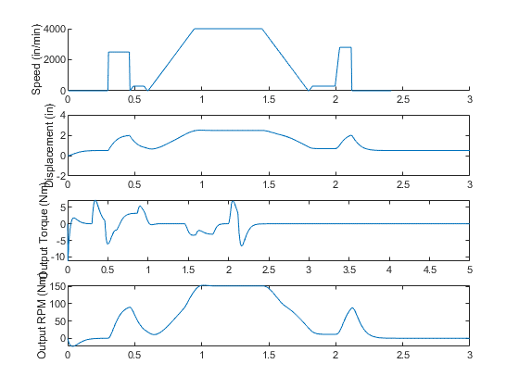

Figure – Simulation of the switching controller

In this case the torque should only be a maximum of 9Nm for the speed range. This shows that the motor has adequate performance.

# Experimental Fine-tuning

Since calculations are based on inertia estimates, there is still experimental testing that needs to be done in order to tune the system to its maximum possible performance. The simplest way is to raise the material add/cut speed until failure in loss of tension occurs with the same constants.

If tension loss is present with the initial constants then attempt lower add speeds first to find the operating point where the system never loses tension. Once this is found we use the relationship that the add speed and the gain should multiply to a constant.

For example suppose $2500ipm$ adds with $25rad/s$ gain was a working pair of parameters.

$$C=v_{i}⋅K_{p}=2500⋅25=62500ipm⋅rads^{-1}$$

Then if our target is 3000ipm we would simply solve for $K_{p}$.

$$K_{p}=\frac{C}{v_{i}}=20.8rads^{-1}$$

Since the gain is reduced, this means the dancer stroke will necessarily increase. Assuming the secondary loop gain is $K=1$ we can calculate the steady state displacement $x_{ss}$.

Suppose

$$v_{i}=3000ipm$$

$$v_{o}=4000ipm$$

$$x_{r}=0.25in$$

$$x_{t}=\frac{v_{i}}{60K_{p}}+x_{r}=2.65in$$

$$x_{ss}=\frac{1}{2}\left(x_{r}+x_{t}+\frac{v_{o}}{K_{p}}\right)=3.05in$$

Thus the dancer will not over travel.

# Conclusion

The initial constant estimate via dynamic simulation gives conservative parameters assuming that the maximum allowable torque is below the output of the motor by some margin. This means that extra performance can be gained via experimentation and there is a systematic method to do so based on mathematical descriptions of the control dynamics.